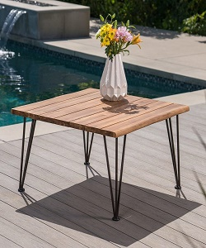

Simple Wood Table

$20.49

Availability: In stock

**Description:**

Simple wood Square table with 4 iron legs to ensure stability and support. A clear striped glossy top provides a place for any items you want to show off, while boxy sled-style base below sports a sleek metallic finish for an on-tred look.this narrow design is perfect look for living room.Assembly is required.